American Lobster Homarus americanus by Melanie Dela Rosa FISH 101

Scientific classification
Kingdom: | Animalia
Phylum: | Arthropoda
Subphylum: | Crustacea
Class: | Malacostraca
Order: | Decapoda
Family: | Nephropidae
Genus: | Homarus
Species: | H. americanus
Binomial name
Homarus americanus
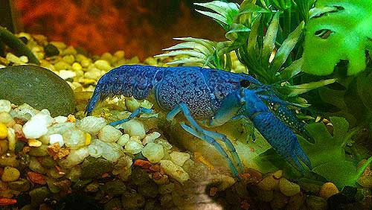
American lobsters are usually either olive-green or greenish-brown. Sometimes they will have orange, reddish, dark green, or black speckles and bluish colors near their joints, but it is rare to find a lobster that is completely blue or completely white. Only 1 out of 2 million crabs turn blue, and their color is caused by a genetic problem. The lobster's body makes too much of a certain protein which turns its shell blue.
NICK NAMES:
Canadian lobster, true lobster, northern lobster, Canadian Reds, or Maine lobster.

WHERE I LIVE:
The American lobster thrives in cold, shallow waters where there are many rocks and other places to hide from predators. It typically lives at a depth of 4–50 m (13–164 ft), but can be found up to 480 m (1,570 ft) below the surface. They are found in the Atlantic coast of North America from Labrador to New Jersey.

“Family” OR CRABS OF SIMILARITY:
Its closest relative is the European lobster Homarus gammarus, which can be distinguished by its coloration and the lack of spines on the underside of the rostrum.
Crystal lobsters, or albino lobsters, are lobsters that do not have any pigment. They are the only lobsters that do not turn red when they are boiled. Instead, these lobsters keep their clear coloring giving them their "crystal" name. Albino lobsters occur only one in a hundred million lobsters. (see picture below).
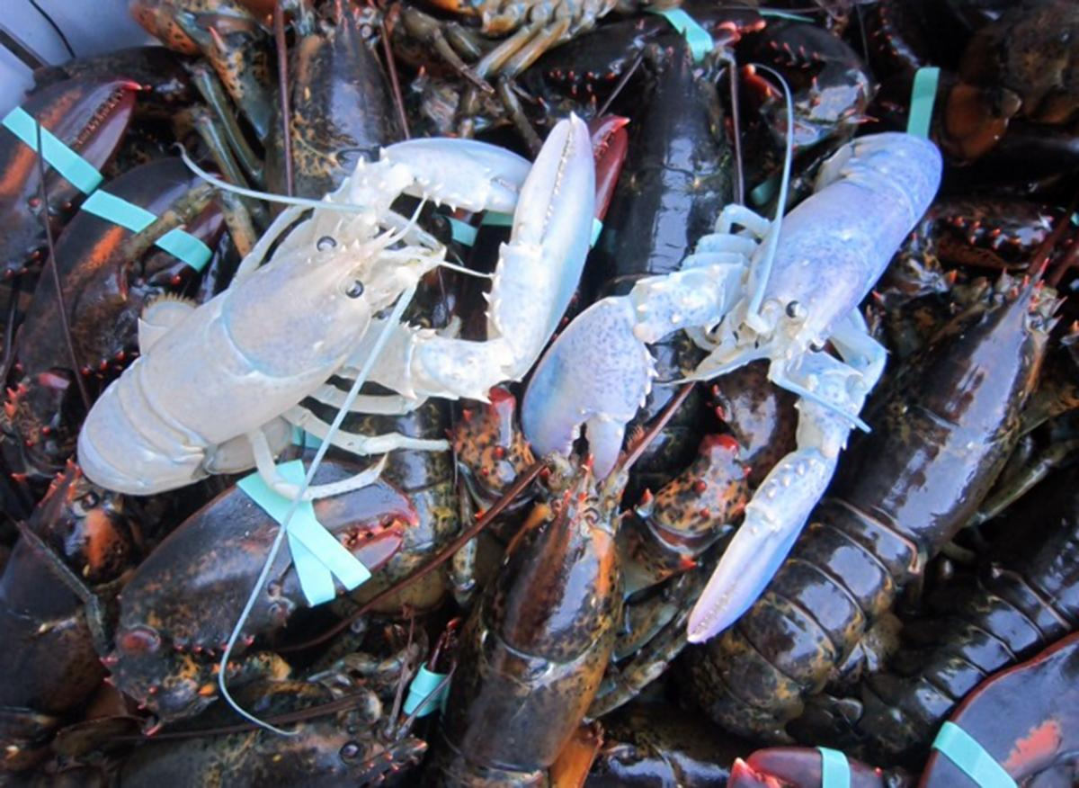

REPRODUCTION & SOME FEEDING FACTORS:
A one pound female can carry about 8,000 eggs while a 9-lb female can carry about 100,000 eggs.
Their reproductive cycle can last up to two years. A female, once sexually mature, will first shed her shell. She then sends a pheromone into the water that simultaneously alerts male lobsters to her presence and serves as a warning to not eat her. That’s because lobsters are occasionally cannibalistic and will attack their own kind when their target is in the vulnerable, soft-shelled stage that follows molting, as a female must be in to conceive. Lobsters will remain hungry rather than attack a female ready to breed. Once a male and female mate the female’s ovaries begin to mature. Six to nine months later, the eggs are extruded from her tail, where they remain, each no bigger than a raspberry kernel. There they remain for still another six to nine months, when they are released into the water as larvae.
“They don’t look very much like lobsters at that point,” says Bayer. When females off spring are born they have no claws, and there’s a very small survival rate. But at the end of two weeks, you have a lobster that has molted four times and is ready to settle to the bottom, ready to begin life.
Of Interest--“If you breed a blue male and blue female, you get all blue offspring,” Robert C. Bayer, executive director of the Lobster Institute stated.
Like dolphins, lobsters use complicated signals to establish social relationships. They sometimes walk hand-in-hand, the old leading the young.

DIET:
The natural diet of H. americanus is dominated by mollusks (especially mussels), echinoderms and polychaetes, although a wide range of other prey items may be eaten, including other crustaceans, brittle stars and cnidarians. Lobsters in Maine have been shown to gain 35-55% of their calories from herring.
The first pair of pereiopods (legs) is armed with a large, asymmetrical pair of claws. The larger one is the "crusher", and has rounded nodules used for crushing prey; the other is the "cutter", which has sharp inner edges, and is used for holding or tearing the prey. They chew with their stomachs. These crabs have a grinding structure for breaking up food which is called the gastric mill (like a set of teeth on their stomachs) which are right behind the eyes and is the size of a walnut in a one-pound lobster.

OTHER PREDATORS:

Juvenile Lobsters~~~During the juvenile stage lobsters look like their adult forms, but they are still smaller and weaker than adults. At this stage they're vulnerable to lots of other ocean creatures. Cod are the lobster's primary enemy, followed by other fish that cruise the ocean floor for food. Tench, flounder, sculpin, wolffish, ocean pout, monkfish, eels, rock gunnels, dogfish and crabs are known to eat young lobsters when given the chance. Juvenile lobsters spend the first four years or so of their lives hiding in crevices or buried in tunnels to keep themselves protected from predators. It takes only a few minutes out of hiding for a young lobster to become a food source.

LIFE CYCLE:
Only one in 1,000 juvenile lobsters remain alive from predators. They can grow between 8 – 24 inches or up to 3 feet long and weigh between 1 – 9 pounds, but are known to weigh up to 44 pounds!!! A young, immature lobster can molt about 25 times a year. An adult lobster usually molts twice a year. Older lobsters molt once every 3-4 years. Since lobsters’ shells usually shed it is hard to determine their age, but are believed to live up to 100 years. The average life span is about 15 years.

SEXUALITY:
You have to observe the swimmerets or appendages of a lobster to determine its sex. A female has soft and feathery appendages while the male has hard, bony ones. Only the females have a small shield between the second pair of walking legs which is the sperm receptacle and also has a wider tail to carry her eggs.

